CHAPTER 3

MOS SKILL LEVEL TASKS

Section I. 11BCHM20 Tasks

M47 MEDIUM ANTITANK WEAPON

SELECT A FIGHTING POSITION FOR AN
M47 MEDIUM ANTITANK WEAPON
071-317-3324

CONDITIONS

Given a standard 1:50,000 military map, an M47 medium antitank weapon (Dragon), and a Dragon gunner in a tactical situation.

STANDARDS

The position selected should—

1. Have natural cover and concealment.

2. Have a clear field of fire.

3. Allow flank shots.

4. Mutually support other antiarmor weapons.

TRAINING AND EVALUATION
Training Information Outline

1. Consider two principal factors when selecting a position for the Dragon:
a. The gunner’s protection.
b. Employment that takes advantage of the capabilities of the Dragon.

Note: It may be necessary to trade off one of these factors for the sake of the other.

2. Use natural cover and concealment. Use the terrain to your advantage for cover from enemy fire and for concealment from enemy ground and air observation. Observe certain precautions when using natural vegetation for concealment (Figure 1).

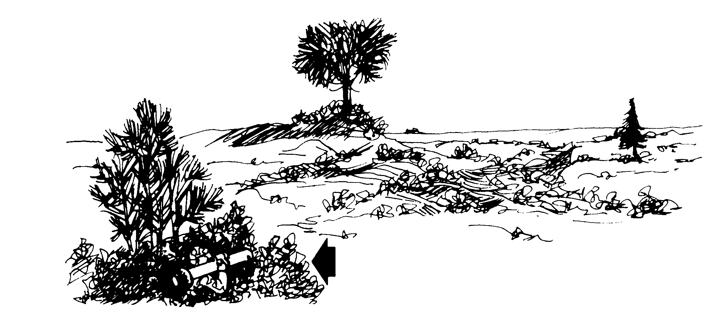
Obstacles that could cause the missile to predetonate or that could interfere in guiding the missile to its target should be cleared.
Any obstruction that might snag the 6” fins should be cleared away from the muzzle of the launcher. The muzzle must be at least 6” above the ground when fired.

Figure 1. Precautions for Dragon firing in vegetation.

3. Engage the enemy with flank shots. Retracing the flight path of a round to its launch site and aiming the weapons at the firing position is harder when the round comes from a direction other than the front (Figure 2).

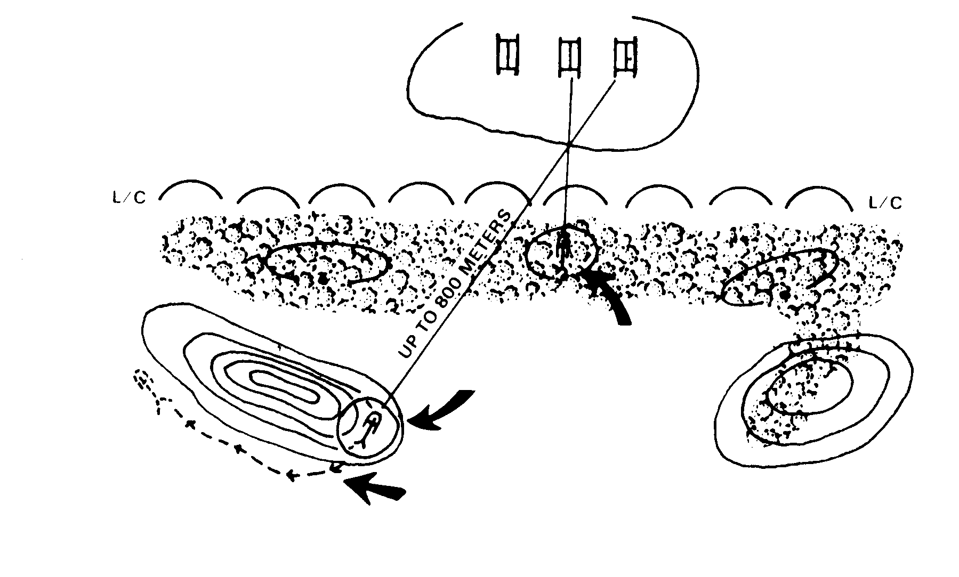
EXPLOIT RANGE AND OBTAIN OBLIQUE FIRES
SECTOR OF
FIRE
FACILITATE MOVEMENT TO SUPPLEMENTARY POSITIONS AND OTHERWISE OPTIMIZE FIRING POSITIONS.
THAN THIS
THIS IS BETTER

Figure 2. Firing from the oblique.

4. Provide a degree of protection for the Dragon gunner through mutual support. Ensure complete, continuous coverage of enemy armor vehicles. Continuous coverage means employing the Dragons in such a manner that their fires interlock with and support other Dragons, TOWs, and tanks.
a. Ensure that sectors of fire overlap. Where possible, ensure coverage of the sector by using more than one antiarmor weapon.
b. Make every effort to position the Dragons so they can engage the enemy armored vehicles that are assaulting another Dragon, TOW, or tank position.

5. Provide security for the gunner if the Dragon is employed away from the squad or platoon. Such security can be provided by forming—
a. A Dragon team consisting of a gunner, a tracker and one round, and one or more riflemen. The riflemen will carry additional rounds and provide local security.
b. An armor-killer team. A Dragon team given extra security personnel, a leader, and an independent mission becomes an armor-killer team. For example, the team may be assigned an antiarmor ambush or the task of filling in gaps during reduced visibility. Normally, this team is fire-team size or larger. Sufficient personnel are necessary to—
(1) Carry the tracker and extra rounds.
(2) Provide supporting fire.
(3) Provide local security.
(4) Maintain communication.
(5) Control the team.

6. The Dragon is highly accurate against stationary targets at ranges to 1,000 meters. Select firing positions to use this advantage. Engaging the enemy at the Dragon’s greatest range makes it harder for the enemy to find and engage the Dragon position. It may also force the enemy to deploy earlier than planned. Because of tracking difficulties, the Dragon’s best engagement ranges against moving targets are between 200 and 800 meters.

7. Prepare alternate and supplementary positions using the same principles used for the primary position.

EVALUATION PREPARATION

Setup: Provide a standard 1:50,000 military map, and an M47 medium antitank weapon (Dragon) at each test site.

Brief Soldier: Tell the soldier to select a fighting position for an M47 medium antitank weapon.

EVALUATION GUIDE

Performance Measures Results

The position must—

1. Have natural cover and concealment. P F

2. Have a clear field of fire. P F
Performance Measures Results

3. Allow flank shots. P F

4. Mutually support other antiarmor weapons. P F

FEEDBACK

Score the soldier GO if all steps are passed. Score the soldier NO-GO if any steps are failed. If the soldier fails any steps, show what was done wrong and how to do it correctly.

REFERENCES

Required Related
None FM 7-8
FM 23-24

